International Court Of Justice

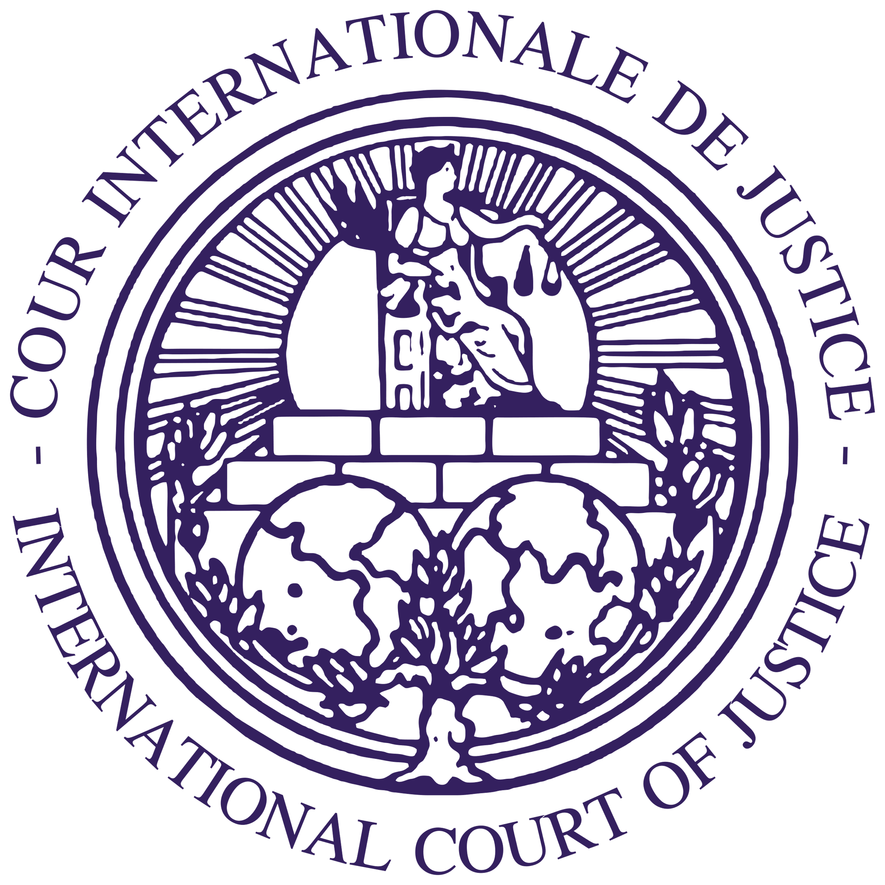

The case of legality of use of force (Serbia and Montenegro v. United Kingdom).

Introduction:
The case of legality of use of force (Serbia and Montenegro v. United Kingdom). Is one of the pivotal moments for Serbia and Montenegro as it aimed to hold the United Kingdom responsible for its atrocious actions such as killing of innocent civilians, the use of prohibited weapons, damaging monuments, intervening in the internal affairs of another state and most importantly using force on another state. This case underlines and highlights the demand for justice for victims that have been unfortunately caught in the cross-fire of the United Kingdom’s acts, the importance of the principles of international law and such laws must be followed, implemented and under no circumstance should they be ignored nor give a state special treatment wither LEDs or HEDs.
Brief case history:
The case of legality of use of force between Serbia and Montenegro v. United Kingdom began in 1999 by Yugoslavia claiming that the United Kingdom has failed to meets its obligations, by which it has violated its international obligations such banning the use of force on another state amongst other obligations which it has also failed to meet.
1) The armed confrontation known as the Kosovo War took place in Kosovo between February 28, 1998, and June 11, 1999. The Federal Republic of Yugoslavia's (Serbia and Montenegro) soldiers, who ruled Kosovo prior to the conflict, engaged in combat with the Kosovo Liberation Army (KLA), an Albanian rebel organization. When the North Atlantic Treaty Organization (NATO) intervened and started airstrikes in March 1999, the war came to a conclusion and Yugoslav forces were forced to leave Kosovo
2) NATO started airstrikes against Serbian military sites on March 24. As a result, all ethnic Albanians in Kosovo were driven out by Yugoslav and Serbian forces, forcing hundreds of thousands of people to flee to Albania, Macedonia (now North Macedonia), and Montenegro. After 11 weeks of bombardment, the NATO air campaign moved on to Belgrade, where it seriously damaged Serbia's infrastructure.
3) A peace agreement detailing the withdrawal of troops and the repatriation of around one million ethnic Albanians along with another 500,000 displaced within the province was signed by NATO and Yugoslavia in June. The majority of Serbs departed the area, while those who stayed sometimes faced retaliation.
4) On 29th of April, the government of the Federal Republic of Yugoslavia (with effect from 4th of February 2003,” Serbia and Montenegro “) filed in the Registry of the court an application instituting proceeding against the United Kingdom of Great Britain and Northern Ireland. (hereinafter” the United Kingdom”) in respect of a dispute concerning acts allegedly committed by the United Kingdom
5)) On 29th of April, immediately after filling its Application, the Federal Republic of Yugoslavia also submitted a request for the indication of provisional measures pursuant to Article 73 of the Rules of Court
6) The Federal Republic of Yugoslavia filed applications to start proceedings and requests for the indication of provisional measures against the United States of America, Canada, the French Republic, the Federal Republic of Germany, the Italian Republic, the United Kingdom of the Netherlands, the Portuguese Republic, the Kingdom of Spain, and the United Kingdom of Belgium on the same day. These disputes arose from the same facts.
7) In accordance with Article 38, paragraph 4, and Article 73, paragraph 2, of the Rules of Court, the Registrar forwarded signed replicas of the request and the application to the UK government in 1999.
8) Since the Court included upon the Bench no judge of Yugoslav nationality, the Yugoslav Government exercised its right under Article 31 of the Statute and chose Mr. Milenko Kreca to sit as judge ad hoc in the case.
9) By Orders of 2 June 1999 the Court, after hearing the Parties, rejected the requests for the indication of provisional measures submitted in the present case by the Federal Republic of Yugoslavia on 29 April 1999. By Orders of the same date, the Court, after hearing the Parties, also rejected the requests for the indication of provisional measures in the nine other cases referred to in paragraph 3 and decided to remove from the List the cases against Spain and the United States of America.
10) By Order dated June 30, 1999, the Court established deadlines for the Federal Republic of Yugoslavia to file a Memorial and the United Kingdom to file a Counter-Memorial. The deadlines were set for January 5, 2000, and July 5, 2000, respectively. The Federal Republic of Yugoslavia duly filed its Memorial, dated 5 January 2000, on January 4, 2000, within the stipulated time frame. It stated that it had produced a single Memorial encompassing this issue as well as the seven other pending matters challenging the legality of use of force.
11) By Order dated June 30, 1999, the Court established deadlines for the Federal Republic of Yugoslavia to file a Memorial and the United Kingdom to file a Counter-Memorial. The deadlines were set for January 5, 2000, and July 5, 2000, respectively. The Federal Republic of Yugoslavia duly filed its Memorial, dated 5 January 2000, on January 4, 2000, within the stipulated time frame. It stated that it had produced a single Memorial encompassing this issue as well as the seven other pending matters challenging the legality of use of force.
Crimes committed under international law:
1) Participating in the bombing of the terrain of the Federal Republic of Yugoslavia, the United Kingdom has acted against the Federal Republic of Yugoslavia in breach of its compulsion refrain from the use force against another State
2) The United Kingdom violated its duty not to intentionally subject a national group to conditions of life calculated to bring about its physical destruction, in whole or in part, by engaging in the above-mentioned activities, particularly by utilizing depleted uranium and causing significant environmental damage
3) Involved in destroying or damaging monasteries, monuments of culture, the United Kingdom has acted against the Federal Republic of Yugoslavia in breach of its obligation not to commit any act of hostility directed against historical monuments, works of art or places of worship which constitute cultural or spiritual heritage of people ;
4) Taking part in killing civilians, destroying enterprises, communications, health and cultural institutions, the United Kingdom has acted against the Federal Republic of Yugoslavia in breach of its obligation to respect the right to life, the right to work, the right to information, the right to health care as well as other basic human rights ;
5) Providing training, arms, finance, equipment, and supplies to terrorist groups—the so-called "Kosovo Liberation Army"—the United Kingdom has violated its duty to refrain from interfering in the internal affairs of other states by acting against the Federal Republic of Yugoslavia;
Arguments that could be made by the prosecution:
A: Bombing of the territory of the Federal Republic of Yugoslavia, the Respondent has acted against the Federal Republic of Yugoslavia in breach of its obligation not to use force against another State ;
B: Using force against the Yugoslav army and police during their actions against terrorist groups, i.e. the so-called ‘Kosovo Liberation Army’, the Respondent has acted against the Federal Republic of Yugoslavia in breach of its obligation not to intervene in the affairs of another State;
C: Attacks on civilian targets, and by inflicting damage, injuries and losses to civilians and civilian objects, the Respondent has acted against the Federal Republic of Yugoslavia in breach of its obligation to spare the civilian population, civilians and civilian objects ;
Arguments that could be made by the defense:
A: it lacks jurisdiction over the claims brought against the United Kingdom by the Federal Republic of Yugoslavia; and/or the claims brought against the United Kingdom by the Federal Republic of Yugoslavia are inadmissible.
B: The Federal Republic of Yugoslavia did not continue the personality and treaty membership of the former Yugoslavia, and thus specifically, it was not bound by the Genocide Convention until it acceded to that Convention (with a reservation to Article IX) in March 2001".
C: As the Federal Republic of Yugoslavia became a new member of the United Nations on 1 November 2000, it follows that it was not a member before that date. Accordingly, it became an established fact that before 1 November 2000, the Federal Republic of Yugoslavia was not and could not have been a party to the Statute of the Court by way of UN membership.
Conclusion:
This case sheds light on an important event that took place in history. Not only that, it calls attention to the importance of maintaining peace, tranquility and prosperity. Both pertinent parties convey how multiple factors wither economic and/or social are vital in the violation of international Law. That is when you, advocates and judges, are liable to step-in and recognize injustice, reinforce international law and have an unwavering need to hold the ones responsible for such heinous acts before things go array which can be accomplished with justness, fairness, impartiality and patience with the hopes of creating a more peaceful world as we are in state, that the world is deprived and is craving of such an accomplishment and it might not be easy but its surely is worth doing.

