The international criminal court (ICC)

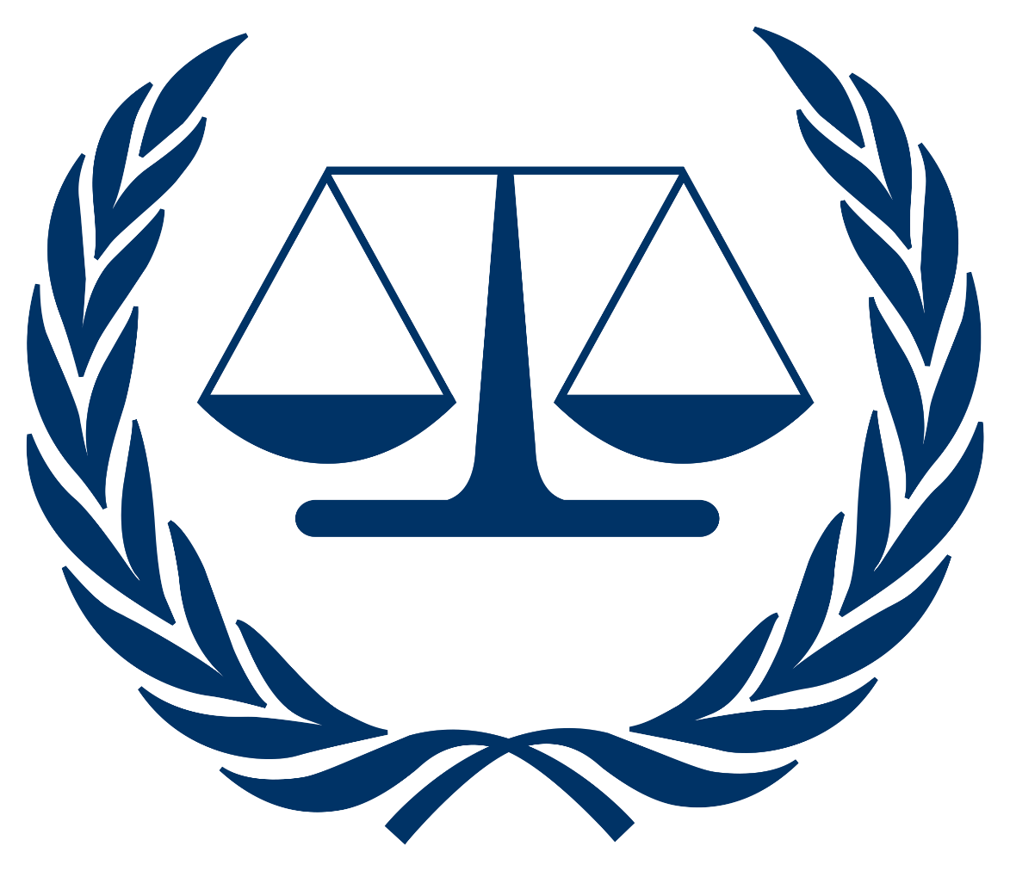

Topic: The prosecutor v. Hissène Habrè

Introduction:
Hissène Habré was the President of the Republic of Chad from 1982 until 1990. During that time, he established a brutal dictatorship which, through its political police, the Bureau of Documentation and Security (Direction de la Documentation et de la Sécurité (DDS)), caused the deaths of tens of thousands of individuals. Residing in exile in Senegal, he was unsuccessfully brought before the Senegalese courts in 2000-2001 at which time the Supreme Court of Senegal confirmed that it did not have jurisdiction to hear the case as the acts allegedly committed by Habré were not criminalised under domestic law. In response to an African Union mandate to prosecute Habré, Senegal amended its legislation to provide for universal jurisdiction over crimes against humanity and acts of torture committed by foreign nationals outside of Senegalese territory.

Brief Case History:
- Ascension to Power (1982):
June 7, 1982: Hissène Habré, a former defense minister, takes control of Chad through a military coup against President Goukouni Oueddei. This event marks the beginning of his presidency.

- Political Repression and Consolidation of Power:
1982-1990: Habré, founder of the National Union for Independence and Revolution (UNIR), establishes a single-party system, suppressing political opposition. The regime employs a pervasive system of surveillance and control, ensuring loyalty through fear and intimidation.

- Formation of the DDS:
1982: Hissène Habré establishes the Documentation and Security Directorate (DDS) with Saleh Younous at its helm. The DDS, conceived as an intelligence agency, quickly transforms into a feared instrument of repression. It operates clandestinely, employing a network of informants and surveillance to stifle any perceived threats to the regime. Under Younous's leadership, the DDS becomes infamous for its ruthlessness, orchestrating mass arrests, torture, and extrajudicial executions.
- Ethnic Targeting and Human Rights Abuses:
1982-1990: Hissène Habré's regime deliberately targets specific ethnic groups, most notably the Hadjerai and Zaghawa, accusing them of supporting opposition movements. The DDS engages in widespread human rights abuses, implementing a policy of collective punishment. Torture techniques include "Arbatachar," a form of suspension from a car tire, adding to the brutality of the regime. Reports surface of secret prisons like the "Piscine" and "Guereda," where systematic abuse and atrocities occur.
- Chadian-Libyan Conflict (1980s):
1980s: Ongoing conflicts with Libya, spurred by territorial disputes and ideological differences, result in a series of battles and proxy wars. Habré positions Chad as an anti-Libyan stronghold, receiving support from the United States and France. The conflict exacerbates regional tensions and contributes to a volatile geopolitical landscape.
- Invasion of Libya:
September 1983: In a bold move, Habré launches a military invasion of Libya, targeting the Aouzou Strip. The invasion is met with fierce resistance from Muammar Gaddafi's forces. The conflict underscores the personal animosity between Habré and Gaddafi, as well as the complex web of geopolitical rivalries in the region.
- Internal Opposition and Rebellion:
1989-1990: Internal dissent against Habré's regime intensifies, fueled by economic hardships and a growing dissatisfaction with authoritarian rule. Idriss Déby, once a key military figure under Habré, defects and leads a rebellion. The rebellion gains momentum, drawing support from disenchanted factions within the Chadian military.
- Ouster and Exile (1990):
December 1990: Idriss Déby's rebel forces, known as the Patriotic Salvation Movement (MPS), capture N'Djamena, effectively ending Hissène Habré's presidency. Habré flees into exile in Senegal, marking the conclusion of a tumultuous era marked by political repression, conflict, and human rights abuses.
- Legacy of Repression:
Hissène Habré's legacy in Chad is one of enduring trauma and scars. The regime's brutal methods, orchestrated by the DDS, have left a profound impact on the collective psyche of the nation. The legacy of political repression, ethnic violence, and human rights abuses continues to shape Chad's social and political landscape, posing challenges to post-Habré governance and reconciliation efforts.

- Post-Exile Period:
Hissène Habré resides in exile in Senegal, where discussions about justice and accountability gain momentum. The international community grapples with addressing the crimes committed during his rule, while victims seek recognition and reparations. The post-exile period becomes a critical phase in Chad's journey toward healing and rebuilding after years of authoritarian rule.

Crimes committed under The Rome Statute:
- Crimes Against Humanity (Article 7):
- Torture (Article 7(1)(f)): Habré was accused of widespread and systematic torture of political opponents, activists, and perceived enemies. The methods of torture included beatings, electric shocks, and other forms of physical and psychological abuse.
- Persecution (Article 7(1)(h)): The regime under Habré was alleged to have targeted specific ethnic groups, opposition members, and other individuals, subjecting them to persecution based on political, ethnic, and religious grounds.
- Enforced Disappearances (Article 7(1)(i)): Numerous individuals disappeared during Habré's rule, and he was charged with the crime of enforced disappearances, involving the abduction and secret detention of individuals.

- War Crimes (Article 8):
- Unlawful Killings (Article 8(2)(a)(i)): The charges included accusations of extrajudicial killings, summary executions, and mass killings of political opponents and civilians perceived as threats to the regime.
- Attacks Against Civilian Populations (Article 8(2)(e)(i)): The regime was accused of intentionally directing attacks against civilian populations, including bombing campaigns and other military actions resulting in civilian casualties.
- Sexual Slavery and Rape (Article 8(2)(e)(vi)): The charges included crimes of sexual violence, such as sexual slavery and rape, committed against women and girls by the security forces under Habré's command.

- Torture (Article 7 and Article 8):
- Habré was specifically charged with overseeing and allowing the systematic use of torture by the DDS, his intelligence agency. This involved not only physical torture but also psychological and sexual abuse.

- Other Crimes:
- Arbitrary Detention (Potentially covered under Article 7 or Article 8): Habré faced charges related to arbitrary detention, as numerous individuals were held without legal basis during his regime.
- Inhumane Acts (Potentially covered under Article 7 or Article 8): Acts causing great suffering or serious injury to body or mental or physical health, as part of a widespread or systematic attack against the civilian population were also included in the charges.

Possible arguments for Prosecution:
The prosecution in the Hissène Habré case should meticulously present a robust case, outlining a pattern of systematic and widespread human rights abuses during his regime in Chad. The prosecution may demonstrated that under Habré's leadership, the DDS engaged in a consistent and deliberate policy of political repression, mass killings, and torture, targeting specific groups based on political, ethnic, and religious grounds. Furthermore, they may argue that as the president, Habré bore command responsibility for the actions of the security forces and failed to prevent or punish those responsible for human rights violations. Witness testimonies, survivor accounts, and documented evidence should be strategically employed to establish a direct link between Habré's rule and the atrocities committed.

Possible arguments for Defense:
The defense counsel may argue that the charges against Habré were politically motivated, aiming to settle old scores rather than seeking objective justice. The defense may also question the credibility of witnesses, suggesting that testimonies were influenced by external factors or that they lacked firsthand knowledge of Habré's decision-making. Additionally, the defense can dispute the extent of Habré's control over the DDS, asserting that he may not have been fully aware of the actions of security forces. Furthermore, contesting the admissibility of certain evidence, raising concerns about its reliability or relevance. Throughout the trial, the defense can aim to create reasonable doubt, challenging the prosecution's case and advocating for a fair and impartial assessment of Habré's actions during his presidency.

Conclusion:
The Hissène Habré case is a pivotal instance in international justice, signifying the determination to hold leaders accountable for severe human rights abuses. The landmark 2016 conviction by the Extraordinary African Chambers highlights the success of regional mechanisms in addressing impunity. Civil society advocacy played a crucial role, sparking important discussions on reparations and acknowledgment for victims and fostering broader conversations on transitional justice. Despite inherent complexities, including debates on international involvement, the trial leaves a lasting impact, influencing regional initiatives and contributing to the ongoing evolution of global justice mechanisms.

