The International Criminal Court (ICC)

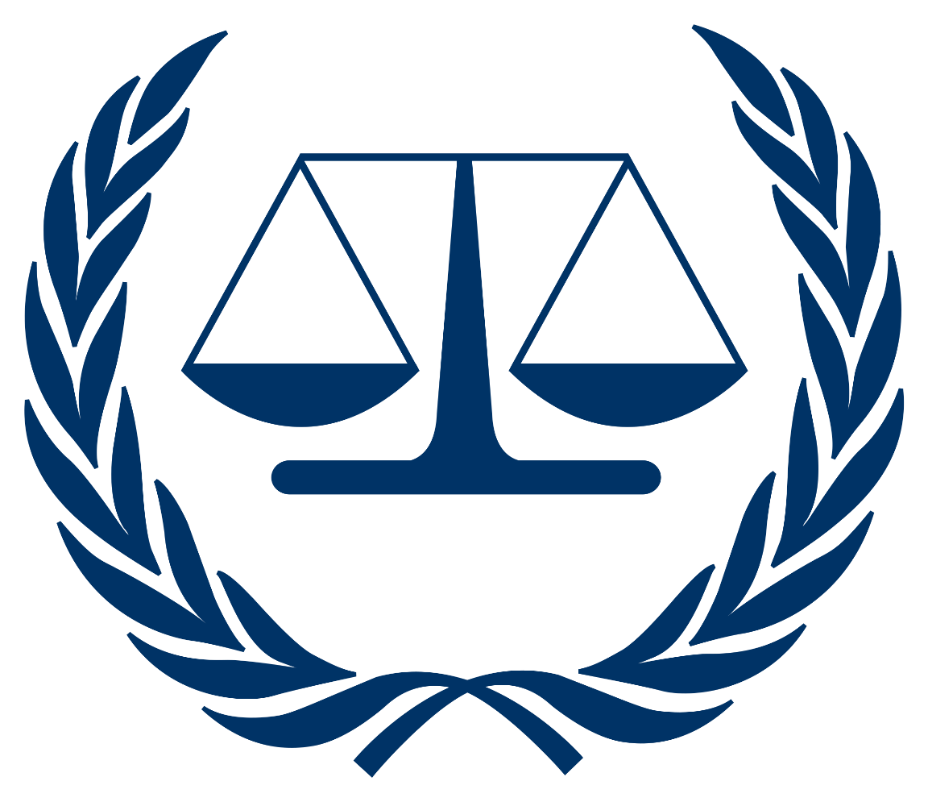

Topic: The Trial of Joe Biden for Complicity in a Genocide

Introduction:
Joseph Robinette "Joe" Biden, Jr is The United States 46th president, he was inaugurated on January 20, 2021. Joe Biden has showed endless support to the Israeli Government from the first day by providing military aid, economic assistance, diplomatic support, strategic cooperation, joint military exercises, technology and innovation partnerships, supporting international organizations. Beyond the provision of hardware and intelligence, the US has reportedly been offering Israel tactical advice on how to conduct its offensive in Gaza. This includes recommendations on deployment strategies, target selection and weapon utilisation.
Israel, with one of the most powerful militaries in the world, routinely attacks Palestinians in Gaza and largely defends this population. So far this year, Israel has killed at least 400 Palestinians, including dozens of children. In 2021 alone Israel killed over 260 Palestinians in Gaza, including at least 67 children in less than two weeks.
Israel has subjected Palestinians and Gaza to a brutal siege for 16 years Israel cut Gaza off from the rest of the world trapping over 2 million Palestinian residence inside, causing severe shortages of life-saving medicines, food, electricity and clean water that make life unbearable. Coverage of what’s happening in Israel and Palestine must include the context of Israel’s decades-long military occupation, races apartheid system and its brutal siege on millions of Palestinians in Gaza.
The root cause of violence in Israel and Palestine is Israel’s decades-long violence and oppression against Palestinians.

Brief Case History:
For over 75 years, Israel has brutally attacked Palestinians daily, killing hundreds of Palestinians every single year, including entire families and children. This daily violence against Palestinians receives little to no mainstream news coverage as Palestinians suffer under horrific conditions.
- How the 2023 war started: The Palestinian Resistance Movement Hamas launched an unprecedented surprise attack on Tel Aviv with thousands of rockets, and sent groups of gun men across the border. At least 200 dead, thousands injured which is why Benjamin Netanyahu ordered the Israeli forces to strike back flattening a high rise building in Gaza city and mobilizing troops across the country. The US defense secretary was also in contact with the Israeli government saying he will work to ensure Israel has the support it needs with no time line for the end of this conflict. Israeli attacks kept intensifying, more residential towers were targeted as well as non residential towers in heavily populated areas. The Israeli Government sent text messages to all those who live in Gaza asking them to quickly evacuate their homes which lead to a large number of Gazans being displaced. By October 15th Israel has killed more than 2670 Palestinian in Gaza including 724 children. Israel cut off all electricity, water and food to the 2 million people inside of Gaza and hasn’t stopped bombing schools, apartment buildings, mosques, a market place and more. At the end of October Israeli ground forces advanced into the Gaza Strip. When communications in the area initially cut off, militants' capacity to coordinate was hindered, but paramedics and humanitarian organizations were also unable to meet the demands of the disasters. In contrast to earlier wars, the ground assault proceeded slowly, with an incremental rise in the quantity of armored vehicles and soldiers. Under terms negotiated by Egypt, Hamas, and Israel, the Rafah border crossing between the Gaza Strip and Egypt opened on November 1 to permit a restricted number of foreign nationals to leave the region for the first time since October 7.
Ever since, in Gaza at least 23,357 people were killed including more than 9,600 children, 6,750 women. More than 59,410 injured including at least 8,663 children and 6,327 women. The number of missing people has officially reached 8,000. In the West Bank, at least 340 people killed, including more than: 84 children, and more than 3949 injured. As for Israel about 1,139 people were killed and those injured are at least 8,730.

- The United States stand on the matter: As Israel continues to plan for a ground invasion opens in a new tab of Gaza, the U.S. sent it a shipment opens in a new tab of armored vehicles following shipments opens in a new tab of U.S-made advanced weaponry, To protect Israel’s back during its Gaza operations, the US deployed two aircraft carrier strike groups and a nuclear submarine carrying tomahawk missiles in the eastern Mediterranean. This intimidating display of military might sends a clear message to any potential adversaries, effectively shielding Israel. Israel has historically been the largest recipient Opens in a new tab of U.S. military assistance — to the tune of $158 billion since the country’s establishment in 1948. That funding has increasingly come under scrutiny in the U.S., including following Israeli forces’ killings of several U.S. citizens. The Biden administration has continued to actively support Israel’s mass-killing campaign while obstructing international efforts to stop the carnage. On December 8, the U.S. singlehandedly vetoed a U.N. Security Council resolution calling for a ceasefire and hostage release. A day later, the Biden administration approved sending Israel $106.5 million worth of tank shells without congressional approval. On December 12, the U.S. voted against a 153-10 U.N. General Assembly vote for a ceasefire and hostage release. In late December, the Biden administration delayed a U.N. Security Council vote for humanitarian aid to Gaza for days while working to water it down. The administration negotiated the removal of the word “cessation” in a call to end fighting, as well as a provision that would have allowed an independent inspection of aid going into Gaza, rather than the Israel-administered checks that have slowed aid shipments to a crawl. The changes were made to avoid another American veto — only for the U.S. to abstain from voting.

During January 2024 as the Secretary of State Antony Blinken concludes his fourth tour of the Middle East since the war in Gaza began, he insisted that the administration of US President Joe Biden “continues to stand” with Israel but that civilian casualties in Gaza remain “far too high”.

Crimes committed under The Rome Statute:

- Crimes Against Humanity (Article 7):
- Murder (Article 7(1)(a));
- Extermination (Article 7(1&2)(b));
- Deportation or forcible transfer of population (Article 7(1&2)(d));
- Imprisonment or other severe deprivation of physical liberty in violation of fundamental rules of international law (Article 7(1)(e));
- Torture (Article 7(1)(f)&(2)(e)));
- Persecution…..(Article 7(1)(h)&(2)(g)));
- The crime of apartheid (Article 7(1)(j)&(2)(h))).
- War crimes (Article 8):
Article 8(2)(a):
- (i) Wilful killing;
- (ii) Torture or inhuman treatment, including biological experiments;
- (iii) Wilfully causing great suffering, or serious injury to body or health;
- (vi) Wilfully depriving a prisoner of war or other protected person of the rights of fair and regular trial;
- (viii) Taking of hostages.
Article 8(2)(b):
- Intentionally directing attacks against the civilian population as such or against individual civilians not taking direct part in hostilities;
- (ii) Intentionally directing attacks against civilian objects, that is, objects which are not military objectives;
- (iii) Intentionally directing attacks against personnel, installations, material, units or vehicles involved in a humanitarian assistance or peacekeeping mission in accordance with the Charter of the United Nations, as long as they are entitled to the protection given to civilians or civilian objects under the international law of armed conflict;
- (iv) Intentionally launching an attack in the knowledge that such attack will cause incidental loss of life or injury to civilians or damage to civilian objects or widespread, long-term and severe damage to the natural environment which would be clearly excessive in relation to the concrete and direct overall military advantage anticipated;
- (v) Attacking or bombarding, by whatever means, towns, villages, dwellings or buildings which are undefended and which are not military objectives;
- (vi) Killing or wounding a combatant who, having laid down his arms or having no longer means of defense, has surrendered at discretion;
- (vii) Making improper use of a flag of truce, of the flag or of the military insignia and uniform of the enemy or of the United Nations, as well as of the distinctive emblems of the Geneva conventions, resulting in death or serious personal injury.

Possible arguments for Prosecution:
- Military Assistance and Impact: The Prosecution Council may highlight the significant military aid provided by the U.S. to Israel, stressing that this support facilitates actions by the Israeli military that might contribute to the genocide happening in Palestine.
- Failure to Prevent: The Prosecution Council may argue that Biden, as the President of the United States, had the capacity and responsibility to prevent or intervene in actions that could lead to genocide. Emphasize any perceived failure on his part to do so.
- Violation of International Law.

Possible arguments for Defense:
A. Lack of Intent: The Defense Council may argue that U.S. support for Israel was not driven by an intent to destroy a particular group but was rooted in longstanding diplomatic, strategic, and historical alliances.
B. Diplomatic and Political Motivations: The Defense Council may highlight that U.S. support for Israel is often influenced by diplomatic and political considerations rather than genocidal intentions.
C. Israel's Right to Self-Defense: Assert that Israel has the right to defend itself against security threats, and U.S. support is consistent with promoting stability and security in the region.
Conclusion:
In summary, U.S. support for Israel, particularly under Joe Biden's presidency, is characterized by longstanding diplomatic, military, and economic ties. The United States provides significant military assistance, engages in diplomatic cooperation, and offers economic aid programs to foster stability and security in Israel. This support is deeply rooted in historical alliances and strategic considerations, contributing to a complex framework of collaboration between the two nations.

