The International Criminal Court (ICC)

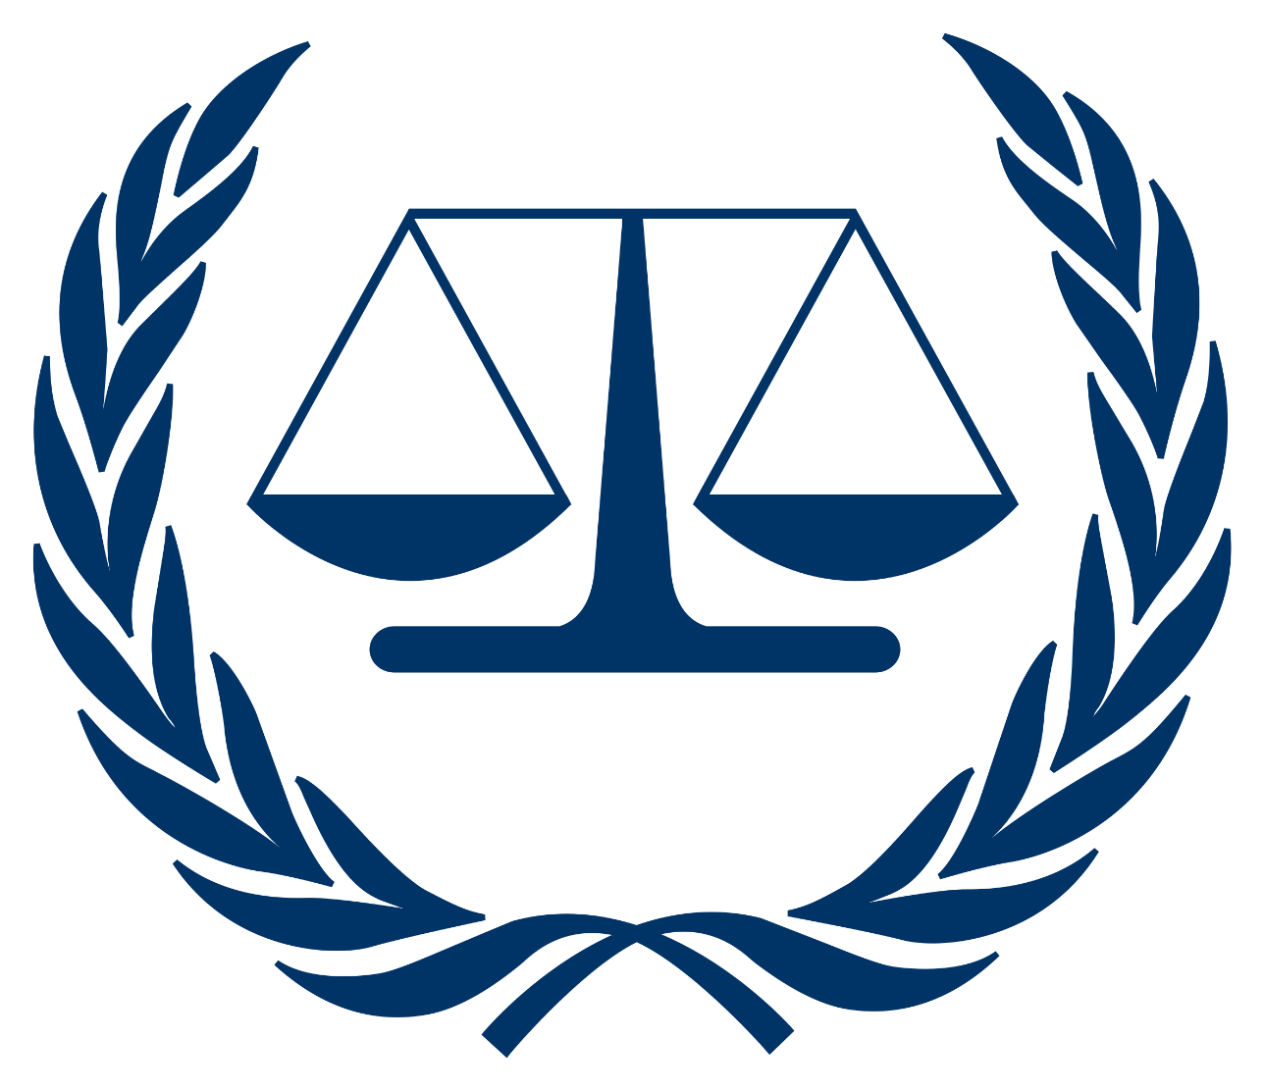

Topic: The prosecutor v. Benito Mussolini

Introduction:
The case against Benito Mussolini before the International Criminal Court (ICC) is a pivotal moment in history, aiming to hold a notorious dictator accountable for his heinous crimes against humanity, war crimes, and genocide. Mussolini's reign, marked by systemic brutality and inhumanity, demands justice for the victims and underlines the importance of international law and human rights.

Brief Case History:
Benito Amilcare Andrea Mussolini was an Italian politician, journalist, and leader of the National Fascist Party. He served as the Prime Minister of Italy from 1922 until his ousting in 1943. During his time in power, Mussolini committed numerous crimes against humanity, war crimes, and acts of aggression. Here is an overview of his case history:
1. Rise to Power: In 1922, Mussolini led the March on Rome, which resulted in King Victor Emmanuel III appointing him as Prime Minister. He dismantled democratic institutions and established a fascist dictatorship in Italy.
2. Abyssinia (Ethiopian) War: In 1935, Mussolini's forces invaded Abyssinia (modern-day Ethiopia). Italian troops, under his command, committed war crimes, including the use of chemical weapons and the deliberate targeting of civilians. This invasion violated international law and led to condemnation from the League of Nations.
3. Spanish Civil War: Mussolini supported Francisco Franco's Nationalist forces during the Spanish Civil War (1936-1939). Italian troops, including the notorious "Blackshirts," committed atrocities against civilians and prisoners of war.
4. Anti-Semitic Laws and Persecution: In 1938, Mussolini enacted anti-Semitic laws in Italy, restricting the rights of Jews. Jewish businesses were confiscated, and Jews faced discrimination and persecution under his regime.
5. World War II and Alliance with Nazi Germany: Mussolini formed a military alliance with Nazi Germany in 1939, leading to Italy's involvement in World War II. Italian forces, under his command, committed war crimes in various countries, including Greece, Yugoslavia, and Libya.
6. Downfall and Execution: As Italy faced military defeats and internal opposition, Mussolini was arrested in 1943. He was later rescued by German forces and established the Italian Social Republic in Northern Italy. However, in 1945, as Allied forces closed in, he was captured by Italian partisans and executed.
7. Legacy: Mussolini's regime left a dark legacy of fascism, aggression, and persecution. His crimes against humanity, war crimes, and anti-Semitic policies have been widely condemned, and he remains a symbol of authoritarianism and tyranny.
Mussolini's actions during his time in power constitute serious violations of international law and human rights, making him a prominent figure in the annals of criminal history.

Crimes committed under The Rome Statute:
- Crimes Against Humanity (Article 7): Mussolini's regime systematically committed crimes against humanity, including persecution and extermination, against political opponents and targeted ethnic and religious groups, particularly Jews. The anti-Semitic laws enacted in 1938 led to widespread discrimination, deportation, and death for many Italian Jews.

- War Crimes (Article 8): Under Mussolini's command, Italian forces committed war crimes during various conflicts, including the Second Italo-Ethiopian War and the Spanish Civil War. These crimes include the use of chemical weapons, unlawful killings of civilians, and intentional attacks on non-military targets.

- Crimes of Aggression (Article 8 bis): Mussolini's aggressive policies and invasions of other countries, such as Ethiopia in 1935, constitute crimes of aggression under the Rome Statute. His military campaigns were characterized by illegal use of force and the violation of the territorial integrity and sovereignty of other states.

- Genocide (Article 6): Mussolini's anti-Semitic laws and policies led to the systematic persecution and deportation of Jews, with the intent to destroy, in whole or in part, a national, ethnical, racial, or religious group. These actions meet the criteria for genocide as outlined in Article 6 of the Rome Statute.

These offenses underline the gravity of Mussolini's actions, making him liable for prosecution under the Rome Statute of the International Criminal Court. His crimes against humanity, war crimes, crimes of aggression, genocide, and command responsibility represent a dark chapter in human history, emphasizing the importance of accountability under international law.

Possible arguments for Prosecution:
A. Systematic Atrocities: The prosecution can present overwhelming evidence showcasing Mussolini's regime's systematic and widespread commission of crimes. Testimonies, documents, and historical records provide irrefutable proof of his culpability.
B. Command Responsibility: Mussolini, as the leader, held command responsibility for the actions of his subordinates. His knowledge of the atrocities and his failure to prevent or punish these crimes establish his liability under international law.
C. Violations of International Treaties: Mussolini's regime violated multiple international treaties and conventions, including the Geneva Conventions. The use of chemical weapons and other war crimes constitutes blatant disregard for established international norms.
Possible arguments for Defense:
A. National Sovereignty: The defense might argue that Mussolini's actions were motivated by national sovereignty and stability. However, such arguments should be weighed against the magnitude of human suffering and loss caused by his regime's actions.
B. Historical Context: While historical context is important, it does not absolve Mussolini of his crimes. The defense might attempt to contextualize his actions within the political climate of the time.
C. Lack of Direct Involvement: The defense could assert that Mussolini was not directly involved in commanding specific criminal acts.
Conclusion:
The prosecution of Benito Mussolini before the ICC signifies a commitment to justice and the prevention of future atrocities. The weight of evidence, coupled with his command responsibility, demands a fair and impartial trial. This trial is not just about holding one individual accountable; it is a testament to the world's determination to ensure that crimes against humanity, war crimes, and genocide are met with unwavering justice. As delegates, our duty is to pursue truth, acknowledge historical injustices, and reinforce the principles of international law for a more just and peaceful world.

